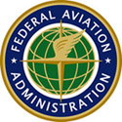

U.S. Department of Transportation
FEDERAL AVIATION ADMINISTRATION

REGULATORY EVALUATION

Additional Revisions to the Certification of Aircraft and Airmen For the Operation of Light- Sport Aircraft

NOTICE OF PROPOSED RULEMAKING
(14 CFR PARTS 43, 61, 91, 141)

Office of Aviation Policy and Plans
Operations Regulatory Analysis Branch, APO-310
Marquise J. McGraw
February 28, 2008

TABLE OF CONTENTS

EXECUTIVE SUMMARY i
I. INTRODUCTION 1
II. BACKGROUND 1
III. ASSUMPTIONS 5
IV. COST OF PROPOSED CHANGES 6
V. BENEFITS OF THE PROPOSED RULE 14
VI. CONCLUSION 15

EXECUTIVE SUMMARY

This Notice of Proposed Rulemaking (NPRM) proposes to amend the rules for sport pilots and flight instructors with a sport pilot rating. The FAA believes these changes are necessary to address pilot certification issues that have arisen since regulations for the operation of light-sport aircraft were implemented. These changes would align the certification requirements for sport pilots and flight instructors with a sport pilot rating with those requirements currently applicable to other airman certificates.

The total cost of this rule would be approximately $8.2 million ($5.8 million, discounted). Much of this cost ($4.3 million) is attributed to new training requirements for sport pilots who fly aircraft with a maximum airspeed in level flight with maximum continuous power (V_{H}) greater than 87 knots calibrated air speed (CAS). Another substantial portion of the cost ($3.0 million) is attributed to changes to the way in which sport pilot practical exams are administered. Benefits include increased safety for sport pilots flying in conditions requiring navigation by reference to instruments, the ability for pilots of powered parachutes and weight-shift-control aircraft to fly at lower altitudes in other-than-congested areas, and the ability for sport pilots to possess certificates with ratings similar to those of other pilots.

The FAA has determined that this proposed rule would not have a significant economic impact on a substantial number of small entities. This proposed rule would have no significant impact on international trade. This proposed rule does not contain an unfunded mandate.

I. INTRODUCTION
The FAA proposes to amend and reorganize some of the certification rules for sport pilots and flight instructors with a sport pilot rating. The FAA believes these proposed changes are necessary to improve safety for sport pilots and flight instructors with sport pilot ratings. One intended effect of these proposed changes is to ensure more acceptable quality control of the certification process for sport pilots and flight instructors with sport pilot ratings. These proposed changes would enable the FAA to have a more effective regulatory oversight of these airmen. These proposed changes would also increase safety in light-sport aviation by adding new training requirements for sport pilots flying aircraft with a V_{H} greater than 87 knots calibrated airspeed (CAS) and by requiring completion of a practical test in lieu of a proficiency check administered by an authorized instructor to obtain category and class privileges. In addition, the proposed rule would change minimum safe altitude rules for pilots of powered parachutes and weight-shift-control aircraft operating in other than congested areas, allowing these pilots to more fully utilize the capabilities of their aircraft.

II. BACKGROUND
On July 27, 2004, the FAA issued the “Certification of Aircraft and Airmen for the Operation of Light-Sport Aircraft” final rule (69 FR 44772). That rule established the certification and qualification requirements for sport pilots and flight instructors with a sport pilot rating in part 61. The rule also established requirements for the certification, operation, maintenance, and manufacture of light-sport aircraft. Since adopting this rule, the FAA has been evaluating the process for certificating sport pilots and flight instructors with a sport pilot rating. The FAA has determined that changes to pilot and flight instructor certification requirements are necessary to better manage the light-sport aviation program and improve safety.

Under the current regulation, if the holder of a pilot certificate wishes to gain additional aircraft category and class privileges at the sport pilot level, he or she need only complete a proficiency check administered by an authorized instructor. On successful completion of a proficiency check, the authorized instructor provides the certificate holder with a logbook endorsement to exercise sport pilot privileges in the category and class of aircraft for which that proficiency check was administered. The authorized instructor is also required to send FAA Form 8710-11 to the FAA.

Authorized instructors, unlike FAA-designated pilot examiners (DPEs), are not required to receive training on giving proficiency checks or practical tests. Because many instructors may not be familiar with the FAA’s procedures, the FAA does not have records for all sport pilots who have been granted privileges through instructor endorsements. The FAA now believes that a person seeking privileges to operate an additional category and class of light-sport aircraft as a sport pilot should get the suitable category and class rating. This would be consistent with the system for issuing all other FAA pilot certificates and ratings and ensure that records of airman qualification are readily available to the FAA and the National Transportation Safety Board (NTSB) during accident and incident investigations or enforcement actions. This would effectively end the current practice of authorized instructors administering proficiency checks, as DPEs would assume this responsibility. In addition, a pilot possessing a certificate indicating his or her current ratings could verify his or her credentials in case original documents were lost or destroyed. Listing a pilot’s qualifications on his or her airman certificate would also remove the need for a pilot to carry a logbook in flight.

The proposed rule would affect new applicants, current holders of sport pilot certificates, and holders of other pilot certificates with sport pilot privileges. If adopted, the rule would require a new applicant for sport pilot privileges in a category and class of aircraft to complete a practical test given by a DPE. A current holder of a pilot certificate with sport pilot privileges that is not on record with the FAA would have to present evidence of endorsements to a DPE or an FAA inspector to get a new sport pilot certificate indicating his or her current ratings.

The proposed rule would eliminate the requirement for holding a make-and-model endorsement for a specific type of aircraft. It would, however, add specific regulatory provisions for endorsements for the operation of powered parachutes with elliptical wings and aircraft with a V_{H} of less than or equal to 87 knots CAS. Pilots who hold recreational pilot certificates and higher, who are already required to earn privileges to operate additional categories and classes of aircraft through a DPE, would not be affected.

The FAA is proposing to require that flight instructors with a sport pilot rating earn sport pilot instructor ratings indicating suitable category and class privileges on their flight instructor certificates. Regulations for flight instructors with a sport pilot rating (part 61 subpart K) would be moved to subpart H to eliminate confusion by standardizing certification requirements for all flight instructors.

The FAA also believes that current training requirements for sport pilots seeking to operate light sport aircraft with a V_{H} greater than 87 knots CAS should be revised. Specifically, many sport pilots operate aircraft with instrument flying capabilities, but have not received training on how to utilize those capabilities. Also, many student pilots find it difficult to meet the requirement of receiving three hours of training in the sixty days before taking a practical exam. The proposed rule would address these issues while incorporating other changes that would clarify the light-sport aviation rules and better serve the light-sport aviation community.

The FAA seeks to revise minimum safe-altitude requirements for powered parachutes and weight-shift-control aircraft. Currently, powered parachutes and weight-shift-control aircraft pilots must remain at least 1,000 feet above the highest obstacle within a horizontal radius of 2,000 feet when operating over any congested area of a city, town, or settlement, or over any open-air assembly of persons. While the FAA believes that current operating restrictions for powered parachutes and weight-shift-control aircraft over congested areas are appropriate, the agency believes that current restrictions on the operation of powered parachutes and weight-shift-control aircraft over other-than-congested areas are overly restrictive.

The FAA recognizes that the operational characteristics (lower maximum gross weights, slower speeds, and lower climb rates) of powered parachutes and weight-shift-control aircraft enable them to safely operate over other-than-congested areas at altitudes lower than those at which other aircraft are routinely operated. Additionally, many of these aircraft have been designed with the intent of conducting operations at altitudes below those permitted by the current regulation. Requiring these aircraft to operate at altitudes more appropriate to other categories and classes of aircraft significantly decreases their utility to owners and operators. In the event of a forced landing, the slower speeds, lower weights, and greater maneuverability of these aircraft allow for shorter landing distances and lower impact forces. The FAA is therefore proposing to amend §91.119 to allow powered parachutes and weight-shift-control aircraft to be operated in other than congested areas at less than 500 feet above the surface, provided the operation is conducted without hazard to persons or property on the surface.

III. ASSUMPTIONS
In this analysis, the FAA estimated future costs for a 10-year period, from 2008 to 2017. As required by the Office of Management and Budget, the present value of this stream of costs was calculated using a discount factor of 7 percent. All costs in this analysis are in 2006 dollars.

Population
Population of current sport pilots – 5,000
Population of current instructors with a sport pilot rating – 600
Sport pilot population growth rate – population will increase by 400 pilots every two years

Reprinting/ Re-Application
Estimated percentage of pilots and instructors who would have to complete a new FAA Form 8710.11 application – 35%
Average time spent to complete a new application – 10 minutes
Average time required for FAA to review a new application – 15 minutes
Average time required for FAA to reprint a certificate – 10 minutes
Postage cost - $0.41 per certificate
Average time spent driving to/from FSDO if new application required – 2 hours
Car costs - $45
Value of Sport Pilot time - $31.50/hr
Sport Pilot Instructor wage rate - $37.43/hr
DPE wage rate - $108.01/hr
Clerical FAA burdened wage rate - $27.17/hr

Instrument Training
Aircraft Rental for Instrument Training - $95.00/hr
Time required in the air for instrument training – 1 hour
Total time required with an instructor for instrument training – 2 hours
Estimated percentage of sport pilots required to take instrument training – 50%
Number of airplanes affected by instrument training – 927, to increase by 75 airplanes every two years

Practical Exams
Average Cost of Practical Exam when given by an Authorized Instructor - $200
Average Cost of Practical Exam when given by a Designated Pilot Examiner - $350

IV. COST OF PROPOSED CHANGES
a. Cost for Pilots Who Automatically Receive New Certificates

Pilots who were previously given proficiency checks and cleared to fly by authorized instructors would have to get a sport pilot certificate with the proper endorsements. In cases where the authorized instructor provided the relevant information to the FAA, this would result in minimal burden on these pilots, who would automatically receive a new certificate in the mail.
The FAA estimates that roughly 3,250 sport pilots would receive new certificates automatically. Similarly, roughly 390 authorized instructors would receive new certificates automatically. The total number of affected pilots and instructors who would automatically receive new certificates is 3,640. Multiplying that sum by the wage rate and amount of time spent by the FAA clerical employee to enter the application ($27.17*1/6*3640) gives a cost of $16,483. Adding this to mailing costs ($0.41*3640= $1,492) yields a total cost of $17,976 ($16,800 discounted) that would accrue to the FAA.

b. Cost for Pilots and Instructors Who Will Need To File a New Application

The FAA estimates that roughly 1,750 sport pilots would be required to resubmit a new FAA Form 8710.11. The total cost to pilots was determined by multiplying the number of pilot applications by the value of his or her time and time spent completing a new application (1,750*$31.50*1/6 = $9,188). This was then added to travel costs, which includes the value of the pilot’s travel time (1,750*$31.50*2 = $110,250) and car costs (1,750*$45.00 = $78,750). Finally, to estimate processing costs the number of applications was multiplied by the DPE’s wage rate and time spent examining the application (1,750*$108.01*1/4 = $47,254). Therefore, the total cost for pilots in this group would be about $245,000 ($229,000 discounted).

The FAA also estimates that roughly 210 authorized instructors would be affected by the rule. The total cost of the rule for instructors was determined by multiplying the number of applications by the instructor’s wage and time spent completing a new application (210*$37.43*1/6 = $1,310). This was then added to travel costs, which includes the value of the pilot’s travel time (210*$37.43*2 = $15,721) and car costs (210*$45.00 = $9,450). Finally, to estimate processing costs the number of applications was multiplied by the DPE’s wage rate and time spent on the application (210*$108.01*1/4 = $5,671). Therefore, the total cost for instructors in this group would be about $32,000 ($30,000 discounted).

Once the new pilot and instructor applications have been completed, an FAA employee would have to enter the data into the FAA records, and the agency would issue the certificates. There are a total of 1,960 applications that will be entered. Multiplying that sum by the wage rate and amount of time spent by the FAA clerical employee to do so ($27.17*1/6*1960) gives a cost of $8,876 ($8,296 discounted) that would accrue to the FAA.

The total cost for reissuing certificates to pilots and instructors without a current form 8710.11 on file would be roughly $286,000 ($277,000 discounted).

c. Additional Instrument Training Requirements for Pilots of Airplanes with a V_{H} Greater Than 87 Knots CAS
The rule proposes to adjust training requirements for a particular group of sport pilots. The proposed rule would require all sport pilots flying airplanes with a V_{H} greater than 87 knots CAS to receive an endorsement which would be earned by completing one hour of instrument flight training. The FAA estimates that this training may require up to two hours of a pilot’s and flight instructor’s time. One hour of this training must be logged in the air, while the other hour may be needed to obtain and return a rental airplane, to complete ground instruction, to fill out documents upon completion of the training, etc. There would also be a new endorsement required for affected pilots. On completion of this training, which may be taken during initial student training or after, these pilots would receive a logbook endorsement.

The FAA estimates that over 10 years, 12,500 sport pilots would be subject to the extra training. The cost of this training was estimated by first multiplying the total number of affected pilots by the authorized instructor’s wage and the total hours necessary for training (12,500*$37.43*2 = $935,750). Added to this were the value of the pilot’s time during training (12,500*$31.50*2 = $787,500), travel costs (12,500*($45+ $31.50*2) = $1,350,000) and plane rental costs (12,500*$95 = $1,187,500). Over a ten-year period the total cost of earning this required endorsement would be $4.26 million ($3.06 million, discounted). Table 1 below shows how these costs were calculated.
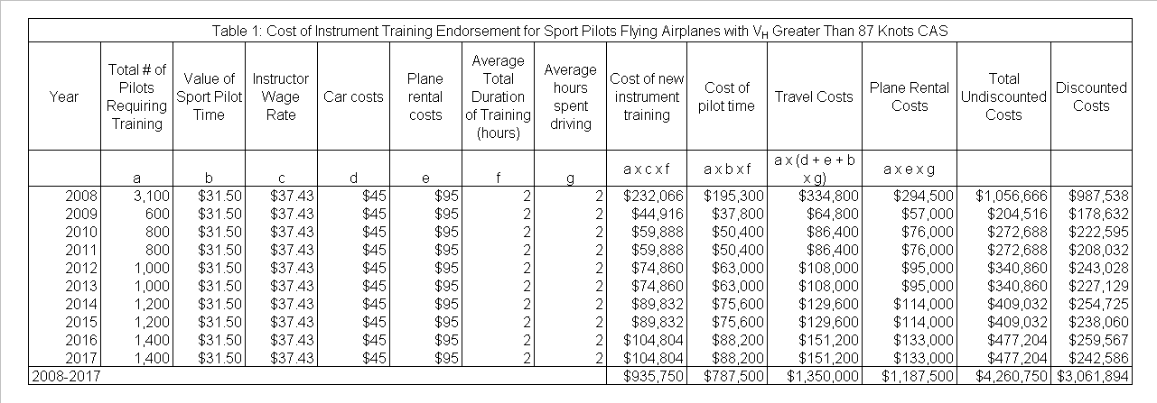
d. Special Endorsement for Powered Parachutes with Elliptical Wings
The FAA is also proposing to require sport pilots (and student pilots seeking a sport pilot certificate) to receive a logbook endorsement if they desire to operate powered parachutes with elliptical wings. However, if a pilot is already authorized to operate such an aircraft, an endorsement would not be required. Therefore, current pilots would not have to take any action as a result of this rulemaking. Future pilots would receive such an endorsement upon completion of their training. Since the FAA anticipates no additional training would be required to receive this endorsement in excess of the normal training necessary to operate this type of aircraft, this provision would not add any additional costs to this rulemaking.

e. Maintenance Requirements and Records for Special Light-Sport Aircraft (SLSA)
The proposed rule includes clarifications and revisions for operators of experimental light-sport aircraft. It would amend §43.1 to except experimental light-sport aircraft previously certificated as special light-sport aircraft from the maintenance and preventive maintenance requirements of Part 43. The proposed rule would require owners and operators to retain a record of the current status of applicable safety directives and to transfer that information at the time of sale of the aircraft. It is estimated that operators would spend no more than two hours per aircraft per year complying with this requirement. As a result, the FAA expects that operators would incur a cost of approximately $680,000 ($470,000 discounted) over a ten-year period. Table 2 below shows how these costs were calculated.
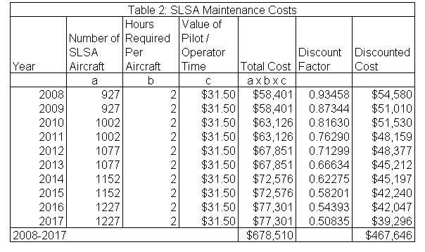

f. Changes to Sport Pilot Practical Test Administration
Currently, authorized instructors are allowed to issue privileges to operate a light-sport aircraft after the completion of a proficiency check. The FAA is modifying this practice by requiring completion of a practical test typically administered by an FAA-designated pilot examiner. DPEs typically charge more than authorized instructors for a practical exam. In Table 3 below, the change in cost is estimated by computing the average difference between the prices charged by a DPE and an authorized instructor. This difference is then multiplied by the projected number of total sport pilot certifications to give the total cost. As shown in Table 3 below, the FAA estimates that this change will cost approximately $3.0 million ($2.0 million, discounted).
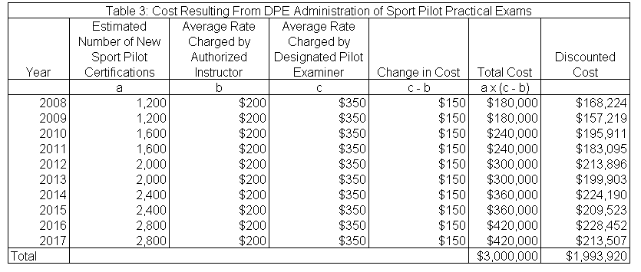
g. Changes to Minimum Altitude Requirements
The FAA is proposing to amend §91.119 to allow powered parachutes and weight-shift-control aircraft to be operated over other-than-congested areas at less than 500 feet above the surface, provided the operation is conducted without hazard to any person or property on the surface. Since the proposed rule allows pilots of these aircraft to fly at a lower altitude than currently allowed over other than congested areas, no extra costs would be incurred.

h. Other Miscellaneous Changes
The proposed rule includes a number of no-cost clarifications and revisions. The proposed rule would clarify the cross-country distance requirements for weight-shift-control aircraft private pilot training. However, this clarification would not impose any new requirements on pilots or instructors and thus would impose no extra costs. The proposed rule would also clarify that an authorized instructor must be on board a powered parachute when providing flight instruction to a student pilot. Since this is required under current regulations, this would not impose any additional costs.

This rulemaking would also reduce the hours of flight training an applicant must receive during the 60 days before taking a practical test. This training requirement would be reduced from three hours to two, for aircraft other than gliders. For gliders, the FAA is proposing to reduce the aeronautical experience that must be logged in preparation for the practical test from 3 hours to 3 training flights. The FAA believes that these proposed changes would better correspond to the time required to prepare for the practical test and recognize the unique characteristics of gliders. The proposed rule would also remove the requirement for student pilots seeking a sport pilot certificate to receive training on the use of radios for VFR navigation and two-way communications. However, these changes will not lead to any changes in the total amount of training time required to obtain certification, and thus there would be no change in costs.

The proposed rule would remove all expired ultralight transition provisions. The proposed rule also contemplates allowing private pilots with powered parachute and weight-shift-control aircraft ratings to receive compensation for production flight testing, which again would incur no costs. The removal of all expired ultralight transition provisions from Part 61 does not affect the cost of this rule. The rule would also allow for the use of special light-sport aircraft in FAA approved courses under Part 141, which would not result in added costs. Similarly, provisions of the rule that serve to clarify current practice or that affect the placement of regulations in the Code of Federal Regulations would also incur no extra costs.

i. Total Cost of this Rulemaking
As shown in Table 4 below, the FAA estimates that the total cost of this rulemaking would be $8.2 million ($5.8 million, discounted). The FAA requests comments on whether these changes in aggregate would result in other noticeable costs and requests that all comments be accompanied by clear and detailed supporting economic documentation.

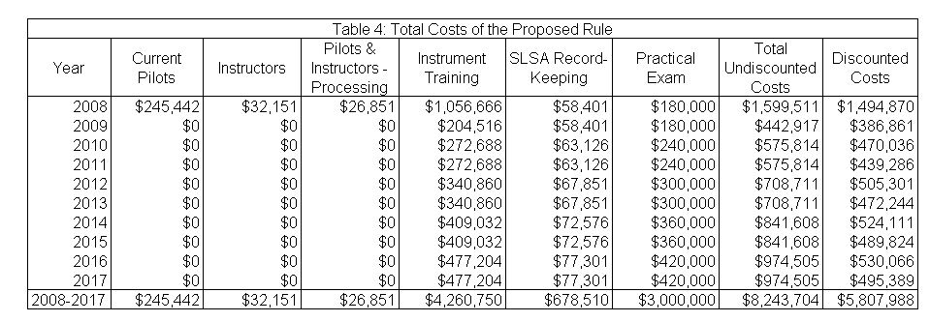

V. BENEFITS OF THE PROPOSED RULE
Currently, sport pilots who fly airplanes with a V_{H} greater than 87 knots CAS are not required to receive any specific amount of flight training on the use of instruments. The proposed rule would require all persons exercising sport pilot privileges in an airplane with a V_{H} of greater than 87 knots CAS receive an endorsement for instrument training. This endorsement can only be obtained through one hour of flight training with an authorized instructor. This rulemaking would increase safety by reducing the potential of an accident, especially at night or in bad weather. Such knowledge is necessary because airplanes with a V_{H} greater that 87 knots CAS are more likely to be used on cross-country flights. On these flights, pilots will have a greater chance of encountering unforecasted meteorological conditions. If a sport pilot does encounter instrument meteorological conditions, this basic instrument training would increase the likelihood of the pilot to be able to safely return to visual meteorological conditions and land the airplane.

Pilots of powered parachutes and weight-shift-control aircraft would also benefit from this rulemaking. They would be allowed to safely operate over other-than-congested areas at altitudes of less than 500 feet, provided the operation is conducted without hazard to persons or property on the surface. Many of these aircraft have been designed with the intent of conducting operations at altitudes below those permitted by the current regulations. This rulemaking would allow these operators to fly at lower altitudes legally. This would allow sport pilots to more fully utilize the operational characteristics of their aircraft.

Another benefit to sport pilots is that the FAA would now have an enhanced ability to replace lost, destroyed, or otherwise unavailable airman credentials. Currently, authorized instructors place the proper endorsements for the operation of a category and class of light-sport aircraft in a pilot’s logbook. If the logbook is lost, destroyed, or otherwise becomes unavailable, it is difficult for a person to obtain proof that he or she was granted privileges to fly a specific type of aircraft unless a record has not been submitted to the FAA. This rulemaking would remove this burden on pilots by issuing certificates with ratings that can be easily verified and replaced if necessary.

Finally, the proposed rule would benefit those pilots of powered parachutes or weight-shift-control aircraft who desire to engage in production flight testing. The rule would allow these pilots to receive compensation for production flight testing of a special light-sport aircraft.

VI. CONCLUSION
The FAA concludes that the proposed rule would improve aviation safety while imposing only moderate costs on the FAA and members of the sport pilot community. Therefore, the FAA has determined the proposed rule would be cost-beneficial. The FAA requests comments on this determination.

The average FAA clerical worker earns at the FG-07 level; their hourly rate, including all benefits, in 2006, was $27.17 per hour. All hourly wage rates for government employees are increased by 32.45% to account for all fringe benefits. This fringe benefits factor was derived from Table 4-5, page 4-22, of the Economic Values for Evaluation of Federal Aviation Administration Investments and Regulatory Programs (Values), DOT; this Draft Final Report, dated December 31, 2004 can be found at the FAA website at http://www.faa.gov/regulations_policies/policy_guidance/benefit_cost/. For this computation, the FAA is using the 2006 Locality Pay Table for the Washington, D.C. area; an FG-07, step 5 earned $19.91 per hour. Multiplying this by 1.3245 equals $27.17 per hour.
5,000 sport pilots x 0.65
600 authorized instructors x 0.65
5,000 sport pilots x 0.35
600 authorized instructors x 0.35

